CSA1708-ARTIFICIAL INTELLIGENCE
LAB EXPERIMENTS

Program 6: write the python program for vacuum cleaner problem
Aim:
To write a Python program to solve the Vacuum Cleaner Problem using an intelligent agent.
Algorithm:
- Start the program.
- Initialize two rooms, A and B, as dirty.
- Place the vacuum cleaner in room A.
- Check whether the current room is dirty.
- If the room is dirty, clean it.
- Move the vacuum cleaner to the other room.
- Repeat until both rooms are clean.
- Display the final room status.
- Stop the program.
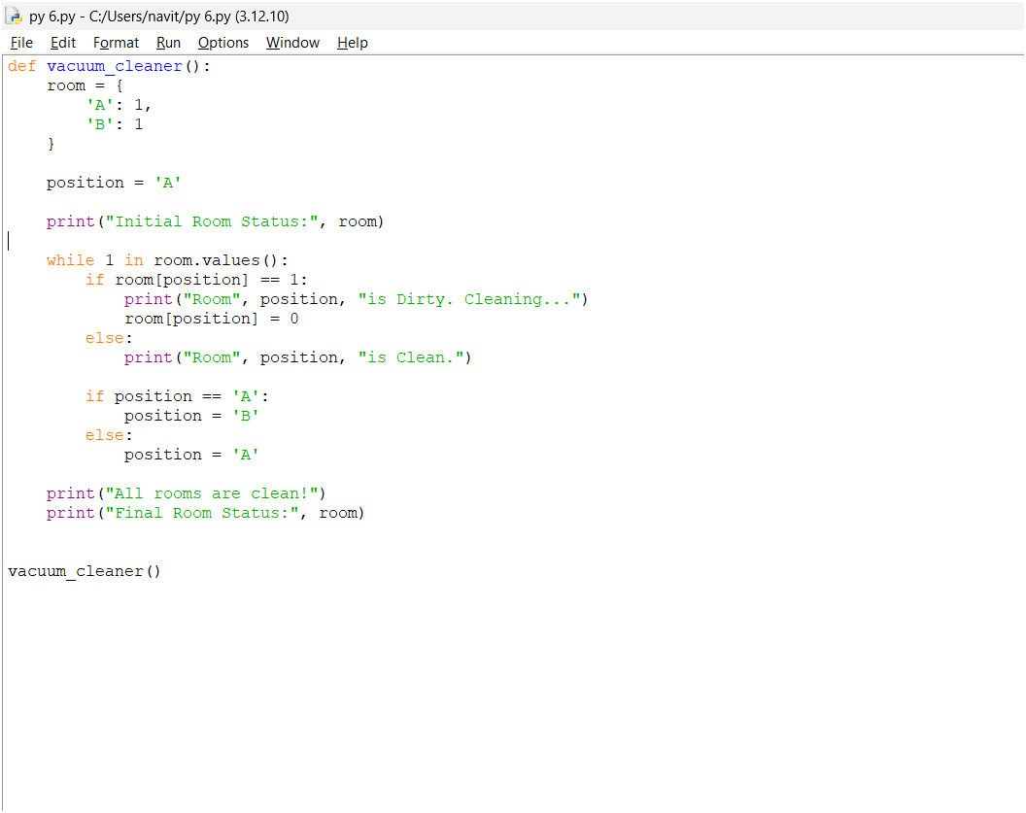
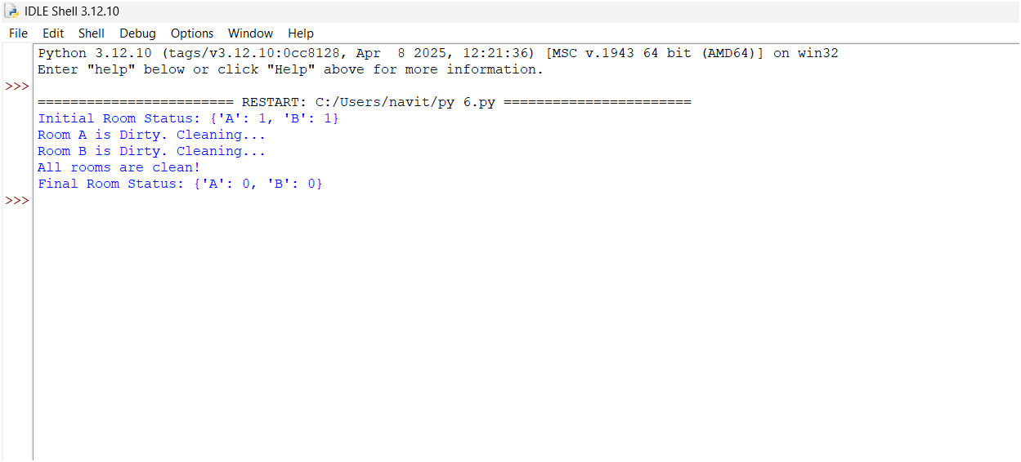
Result:
Thus, the Python program successfully solves the Vacuum Cleaner Problem by cleaning both rooms using a simple intelligent agent.

